**Figure S1**. Inclusion-exclusion diagram.

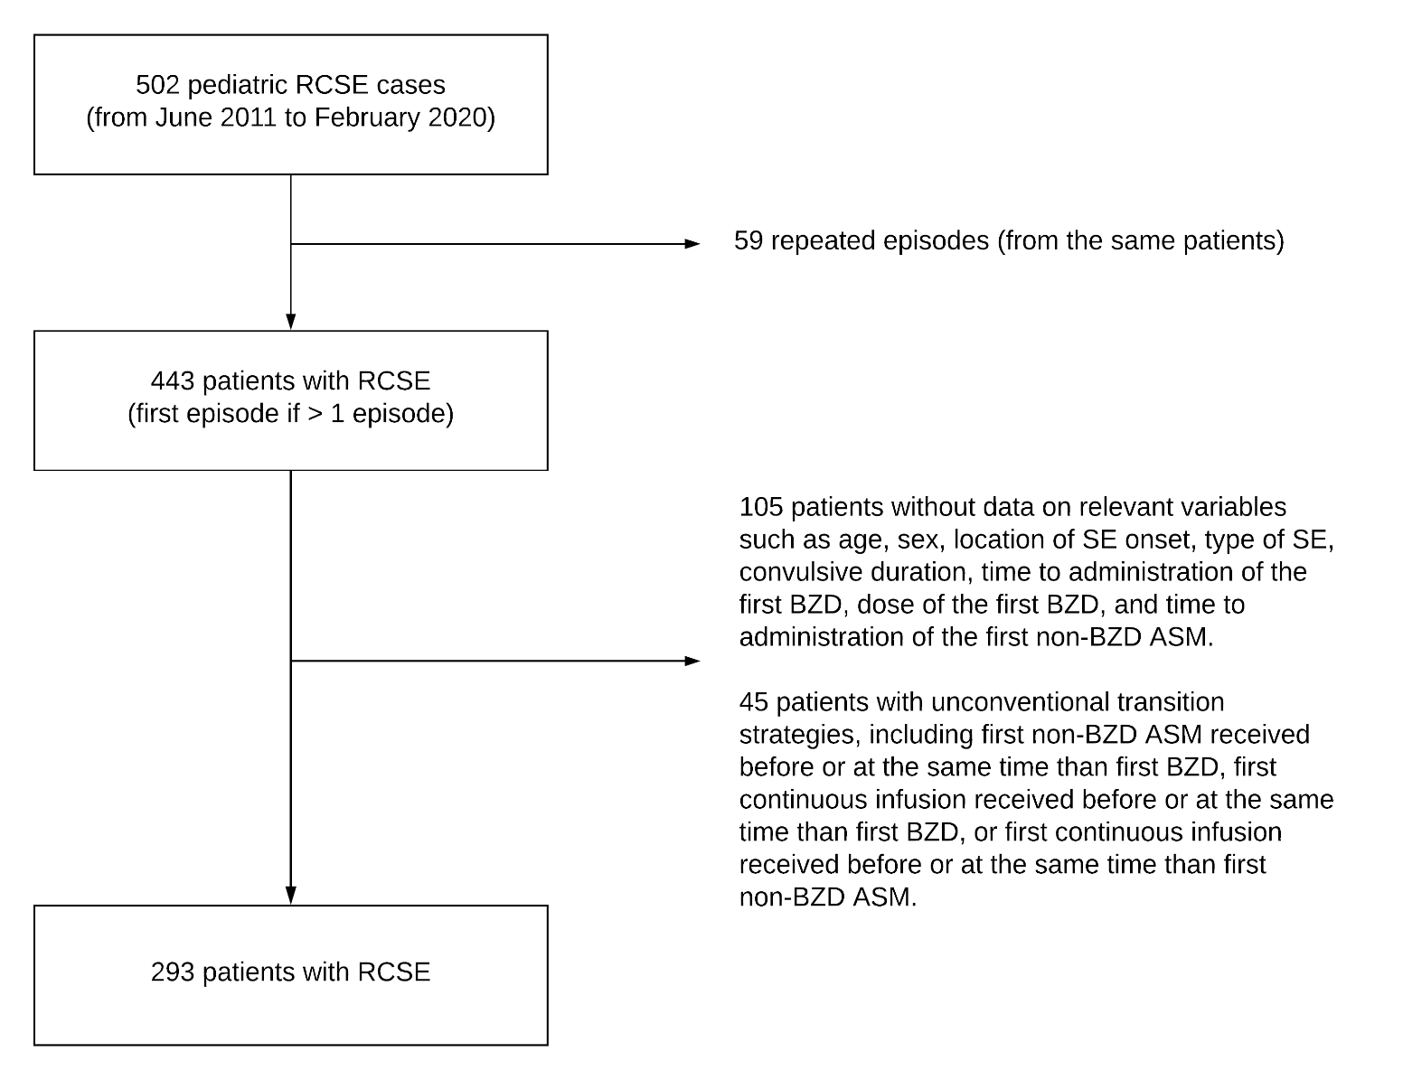

Legend: RCSE: Refractory convulsive status epileptics. SE: Status epileptics. BZD: Benzodiazepine. Non-BZD ASM: Non-benzodiazepine anti-seizure medication.